**Name: Amogh Girish Nagarkar**

**Superset ID: 6403503**

**Exercise 3: Stored Procedures**

**Scenario 1:** The bank needs to process monthly interest for all savings accounts.

* + Question: Write a stored procedure ProcessMonthlyInterest that calculates and updates the balance of all savings accounts by applying an interest rate of 1% to the current balance.

**Scenario 2:** The bank wants to implement a bonus scheme for employees based on their performance.

* + Question: Write a stored procedure UpdateEmployeeBonus that updates the salary of employees in a given department by adding a bonus percentage passed as a parameter.

**Scenario 3:** Customers should be able to transfer funds between their accounts.

* + Question: Write a stored procedure TransferFunds that transfers a specified amount from one account to another, checking that the source account has sufficient balance before making the transfer.

**Scenario 1 Code:**

DELIMITER //

CREATE PROCEDURE ProcessMonthlyInterest()

BEGIN

UPDATE Accounts

SET Balance = Balance * 1.01

WHERE AccountType = 'Savings';

SELECT AccountID, Balance

FROM Accounts

WHERE AccountType = 'Savings';

END;

//

DELIMITER ;

**Output:**

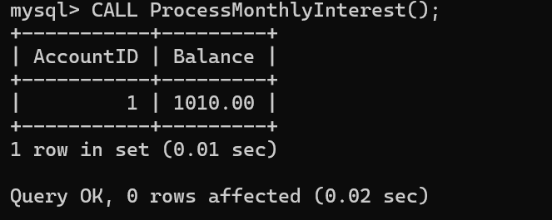

**Scenario 2 Code:**

DELIMITER //

CREATE PROCEDURE UpdateEmployeeBonus(

IN dept_name VARCHAR(50),

IN bonus_percent DECIMAL(5,2)

)

BEGIN

UPDATE Employees

SET Salary = Salary + (Salary * bonus_percent / 100)

WHERE Department = dept_name;

SELECT EmployeeID, Name, Salary

FROM Employees

WHERE Department = dept_name;

END;

//

DELIMITER ;

**Output:**

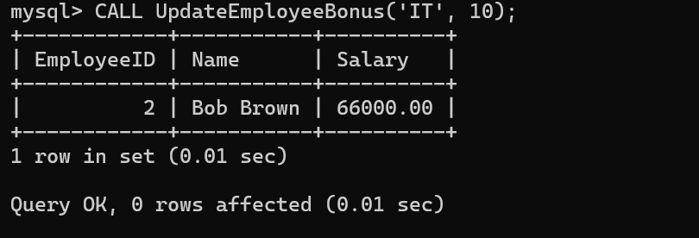

**Scenario 3 Code:**

DELIMITER //

CREATE PROCEDURE TransferFunds(

IN fromAccount INT,

IN toAccount INT,

IN amount DECIMAL(10,2)

)

BEGIN

DECLARE from_balance DECIMAL(10,2);

SELECT Balance INTO from_balance FROM Accounts WHERE AccountID = fromAccount;

IF from_balance >= amount THEN

UPDATE Accounts

SET Balance = Balance - amount

WHERE AccountID = fromAccount;

UPDATE Accounts

SET Balance = Balance + amount

WHERE AccountID = toAccount;

SELECT 'Transfer successful' AS Status;

ELSE

SELECT 'Insufficient funds in source account' AS Status;

END IF;

END;

//

DELIMITER ;

**Output:**

